Form WC31
Mark-out diagram in White Cliffs Mineral Claims District
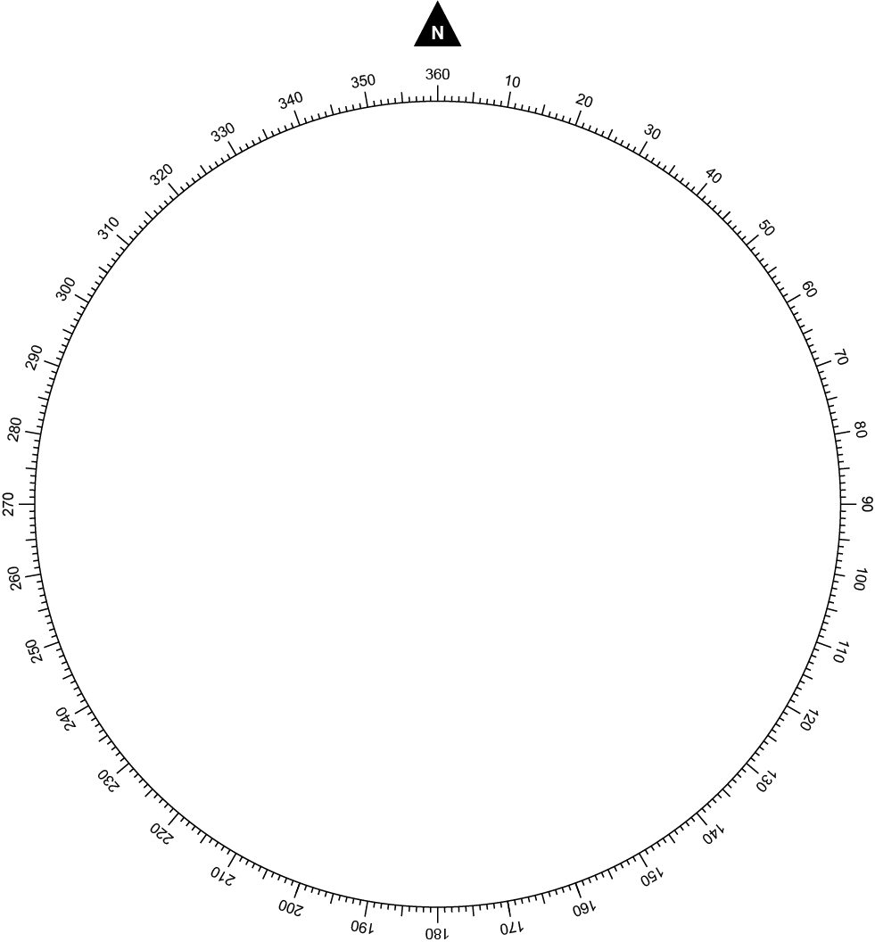

Applicant
Name
Date submitted

Office use only
Claim number
Date granted
Officer | Map ARC

Why do I need to complete a mark-out diagram?
An application for a mineral claim includes a mark-out diagram. A mark-out diagram is a map that identifies the location of your proposed mineral claim in relation to a survey post. The diagram records the distance and bearing from a survey post to the proposed claim. The distance and bearing of each side of the proposed claim is also documented.

How do I survey a mineral claim and complete a mark-out diagram?
You will need a good magnetic compass and a long measuring tape. Compass applications on smartphones are not effective for surveying a mineral claim.
Survey posts in the opal fields are generally taller than ordinary star pickets. Survey posts are also painted in an alternating black and white scheme. Maps of the location of survey posts are available from the Lightning Ridge office or can be viewed online at MinView.
To complete a mark-out diagram:
Figure 1 Illustration of a completed mark-out diagram.
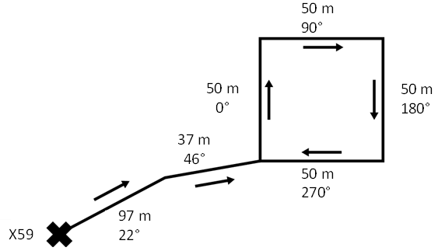
- Place an X on the mark-out diagram and write the name of the survey marker next
to it.
- For all segments of your diagram, include the distance, bearing and an arrow indicating the direction you were looking when you recorded the bearing.
- Measure the distance and bearing from the survey post to your closest claim marker.
- Proceed in a clockwise direction around your claim recording the distance, bearing and direction for each side.
Note: In the White Cliffs Mineral Claims District, there are some situations where it may be more appropriate to use GPS coordinates and then calculate the distance and bearing rather than using a compass and measuring tape. This includes where there are large distances from the survey marker post to the proposed mineral claim. If GPS coordinates are used to calculate the distance and bearing, this needs to be indicated on the measuring toolbox on the mark-out diagram.

Is there anything else I should be aware of to complete a mark-out diagram?
The distance, bearings and directions recorded on the mark-out diagram must be clear. Additionally, do not copy an existing or old survey, as they can be inaccurate. The Department will only accept mark-out diagrams that are clear and accurate.
Additional considerations to record accurate distance and bearings:
- Remove personal metal objects and stand well behind steep posts when doing bearings.
- Do not lie your measuring tape flat on the ground or stretch it too much.
- Avoid one long measurement by measuring segments of less than 100 m.
- Record bearings in the opposite direction to check original bearings are 180 degrees different.
- Use only one corner of the claim to record distance and bearing from the survey post.

Do I need photographic evidence of my mark-out?
Yes. An application for a mineral claim also includes photographic evidence of each individual marker post installed on the corners of the proposed claim that shows the following:
- Boundary of claim indicated through trenches at least 150mm deep or stone walls at least 150mm high for distance at ease one meter from each marker post.
- Possession notice installed on northernmost corner of claim.
- Possession notice has details of proposed mineral claim including dimensions of land, date of mark-out as well as name and address of the applicant.
If you require assistance or more information, please contact:
Mining, Exploration and Geoscience
Small-Scale Titles Team
Phone: +61 2 6820 5200
whitecliffs@regional.nsw.gov.au

© State of New South Wales through Regional NSW 2023. The information contained in this publication is based on knowledge and understanding at the time of writing in September 2023. However, because of advances in knowledge, users are reminded of the need to ensure that the information upon which they rely is up to date and to check the currency of the information with the appropriate officer of the Regional NSW or the user's independent adviser.

Privacy statement

This information is collected by the Department for the purposes of assessing an application for an authorisation or an application associated with an authority as required by the Mining Act 1992 or Mining Regulation 2016.

This information may also be used by the Department to comply with its public register and record-keeping requirements under the Mining Act 1992 and Mining Regulation 2016, to confirm applicant details in the event that subsequent applications are made and to establish and maintain databases to assist the Department with its work generally.

Except for purposes required by law, your personal information will not be disclosed to third parties unless the disclosure is directly related to the purpose for which the information was collected, and the Department has no reason to believe you would object to the disclosure or you are reasonably likely to have been aware or have been made aware, that information of that kind is usually disclosed to that other person or body, or the Department believes on reasonable grounds that the disclosure is necessary to prevent or lessen a serious and imminent threat to the life or health of the individual concerned or another person.

You may apply to the Department to access and correct any personal information the Department holds about you if that information is inaccurate, incomplete, not relevant or out of date.

Version 1.1 September 2023

