Mark-out diagram in the White Cliffs Mineral Claims District
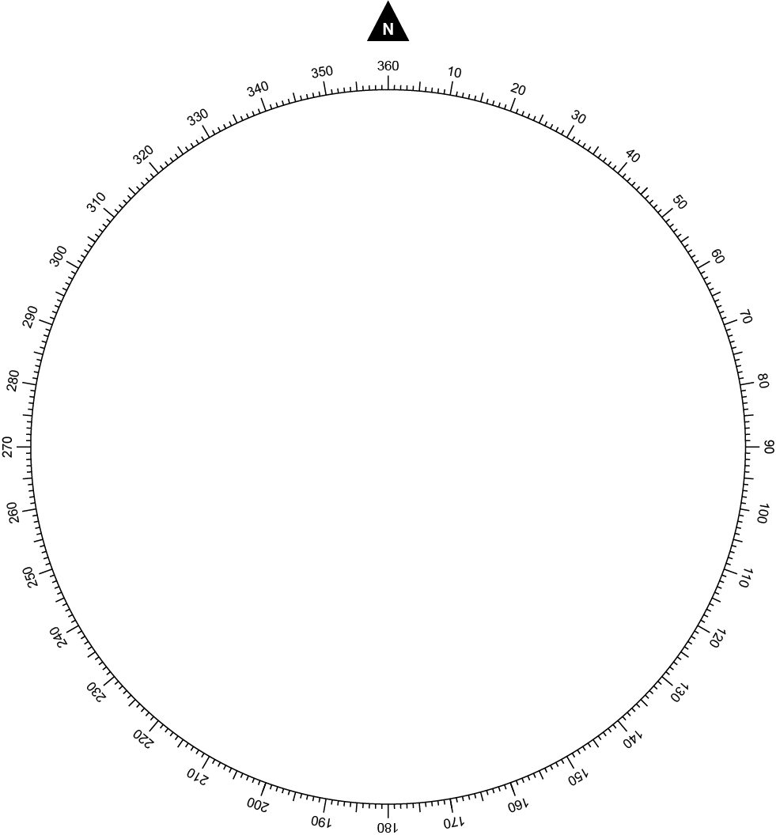

Applicant
Name
Date submitted
Measuring tool for distance and bearing | Compass and tape  GPS coordinates and then calculate distance and bearing

Office use only
Claim number
Date granted
Officer | ARC

Why do I need to complete a mark-out diagram?
An application for a mineral claim includes a mark-out diagram. A mark-out diagram is a map that identifies the location of your proposed mineral claim in relation to a survey post. The diagram records the distance and bearing from a survey post to the proposed claim. The distance and bearing of each side of the proposed claim is also documented.

How do I survey a mineral claim and complete a mark-out diagram?
You will need a good magnetic compass and a long measuring tape. Compass apps on smartphones are not effective for surveying a mineral claim.
Survey posts in the opal fields are generally taller than ordinary star pickets. Survey posts are also painted in an alternating black and white scheme. Maps of the location of survey posts are available from the Lightning Ridge office or can be viewed online at MinView.
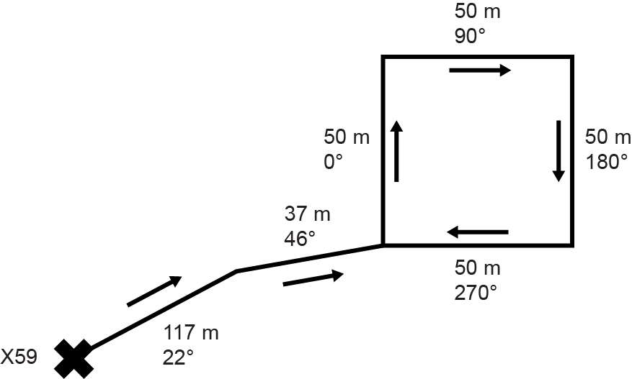
To complete a mark-out diagram you should:
- Place an X on the mark-out diagram and write the name of the survey marker next
to it.
- For all segments of your diagram, include the distance, bearing and an arrow indicating the direction you were looking when you recorded the bearing.
- Measure the distance and bearing from the survey post to your closest claim marker.
- Proceed in a clockwise direction around your claim recording the distance, bearing and direction for each side.
Figure 1 Illustration of a completed mark-out diagram.
Note: In the White Cliffs Mineral Claims District, there are some situations where it may be more appropriate to use GPS coordinates and then calculate the distance and bearing rather than using a compass and measuring tape. This includes where there are large distances from the survey marker post to the proposed mineral claim. If GPS coordinates are used to calculate the distance and bearing, this needs to be indicated on the measuring toolbox on the mark-out diagram.

Is there anything else I should be aware of to complete a
mark-out diagram?
The distance, bearings and directions recorded on the mark-out diagram must be clear. Additionally, do not copy an existing or old survey, as they can be inaccurate. The Department will only accept mark-out diagrams that are clear and accurate.
Additional considerations to record accurate distance and bearings:
- Remove personal metal objects and stand well behind steep posts when doing bearings.
- Do not lie your measuring tape flat on the ground or stretch it too much.
- Avoid one long measurement by measuring segments of less than 100 m.
- Record bearings in the opposite direction to check original bearings are 180 degrees different.
- Use only one corner of the claim to record distance and bearing from the survey post.
Contact the Small-Scale Titles Team for further assistance at 6820 5200 or white.cliffs@regional.nsw.gov.au

© State of New South Wales through Regional NSW 2022. The information contained in this publication is based on knowledge and understanding at the time of writing (December 2022). However, because of advances in knowledge, users are reminded of the need to ensure that the information upon which they rely is up to date and to check the currency of the information with the appropriate officer of the Regional NSW or the user’s independent adviser.

